SIMATS ENGINEERING (SAVEETHA SCHOOL OF ENGINEERING)
Department of Computer Science and Engineering

ASSESSMENT TOOL 1 – Coding Challenge Task

Course Code: | CSA06 | Course Title: | Design and Analysis of Algorithms
CO Assessed: | CO4: Articulation (BL4, BL5) | Assessment: | Assessment Tool 1 – Coding Challenge Task
Weightage: | 40% of CIA | Total Marks: | 100
CO4 Statement: | Solve optimization problems using dynamic programming and greedy strategies.
Student Name: | A.Siva suraj sai | Reg. No.: | 192425276
Section / Batch: | Slot-C | Date: | 20-08-2026

Instructions to Students
- Answer the following question. Total Marks: 100.
- Carefully analyze the given questions.
- Write clear code for the given problem.
- Analyze the Time complexity and Space complexity of your code using dynamic programming and greedy strategies

Question Type | Focus Area | Questions
Coding Challenge Task | Focus on Code and analyze optimization problems using dynamic programming and greedy strategies | Q1

SECTION A – Coding Challenge Task

Q2. Unbounded Knapsack
A manufacturing unit produces items where each type of item can be used multiple times without restriction. Given
weights and profits of items, the goal is to maximize total profit while staying within a given capacity. Since items
are reusable, the problem differs from 0/1 Knapsack. Apply Dynamic Programming to compute the maximum
profit.
Sample Input:
n = 3
Values = 10 30 20
Weights = 5 10 15
W = 100
Expected Output:
Maximum Profit = 300

Unbounded Knapsack Using Dynamic Programming
Aim
To implement the Unbounded Knapsack Problem using Dynamic Programming and determine the maximum profit that can be obtained within a given capacity, where each item can be selected multiple times without restriction.
Problem Statement
A manufacturing unit produces different types of items. Each item has a specific weight and profit. The manufacturing unit has a knapsack with a fixed maximum capacity. Unlike the 0/1 Knapsack Problem, an item can be selected any number of times. The objective is to select items in such a way that the total weight does not exceed the given capacity and the total profit is maximized.
Given Input:
Number of Items (n) = 3
Values = 10 30 20
Weights = 5 10 15
Maximum Capacity (W) = 100
Expected Output:
Maximum Profit = 300
Algorithm
- Start the program.
- Read the number of items n.
- Read the profit/value of each item.
- Read the weight of each item.
- Read the maximum capacity W.
- Create a DP array dp[0...W] and initialize all elements to zero.
- Create a choice array to store the selected item for each capacity.
- For every capacity from 1 to W, check all available items.
- If the weight of an item is less than or equal to the current capacity, calculate the new profit using dp[capacity - weight] + value.
- Compare the calculated profit with the current DP value and store the maximum value.
- Store the selected item in the choice array.
- After completing the DP table, dp[W] contains the maximum possible profit.
- Trace the choice array to identify the items selected.
- Calculate the total weight and total profit.
- Display the DP table, selected items, capacity utilization, and maximum profit.
- Stop the program.
Pseudocode
BEGIN

READ n
READ values[0...n-1]
READ weights[0...n-1]
READ W

CREATE dp[0...W]
INITIALIZE dp[] = 0

CREATE choice[0...W]
INITIALIZE choice[] = -1

FOR capacity = 1 TO W

FOR i = 0 TO n-1

IF weights[i] <= capacity THEN

new_profit =
dp[capacity - weights[i]] + values[i]

IF new_profit > dp[capacity] THEN

dp[capacity] = new_profit
choice[capacity] = i

END IF

END IF

END FOR

END FOR

CREATE selected[0...n-1]
INITIALIZE selected[] = 0

capacity = W

WHILE capacity > 0 AND choice[capacity] != -1

item = choice[capacity]

selected[item] = selected[item] + 1

capacity = capacity - weights[item]

END WHILE

total_weight = 0
total_profit = 0

FOR i = 0 TO n-1

total_weight =
total_weight + selected[i] * weights[i]

total_profit =
total_profit + selected[i] * values[i]

END FOR

DISPLAY DP TABLE
DISPLAY SELECTED ITEMS
DISPLAY TOTAL WEIGHT
DISPLAY MAXIMUM PROFIT

END

Code: 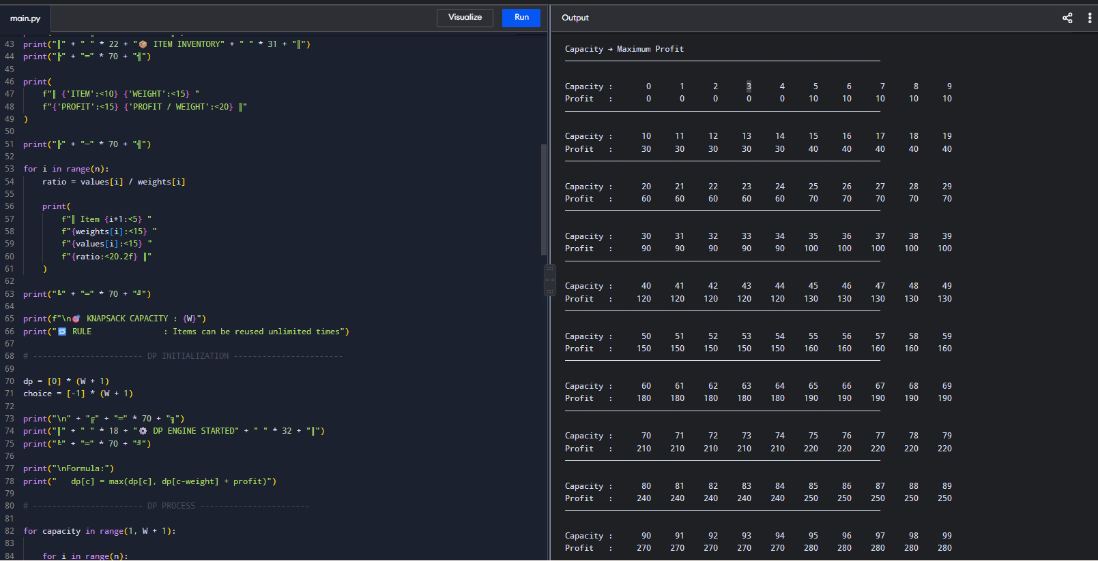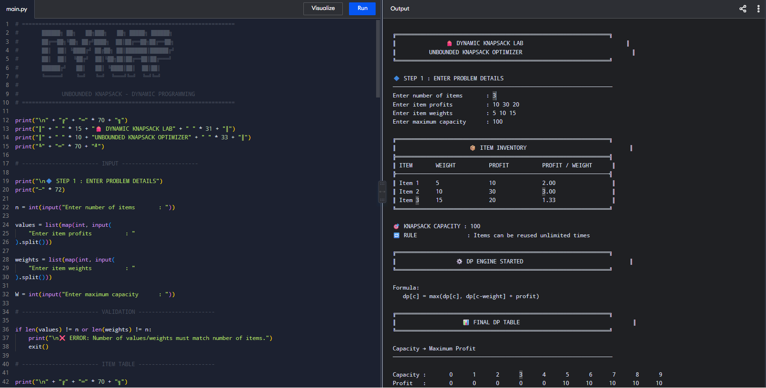
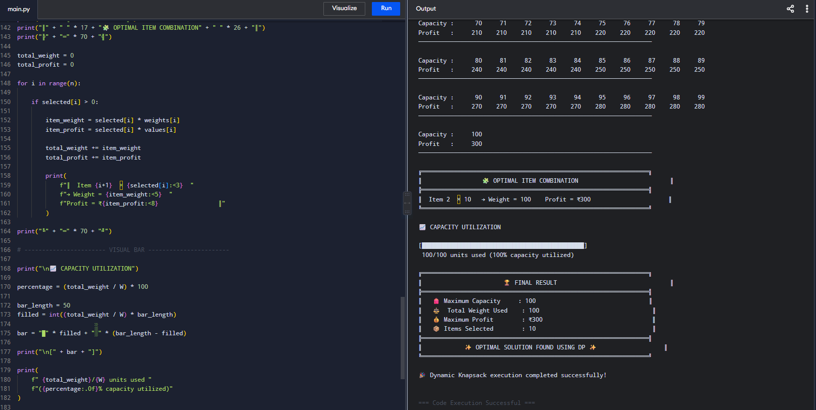
Dynamic Programming Formula
dp[c] = max(dp[c], dp[c - weight[i]] + value[i])
Here, dp[c] represents the maximum profit that can be obtained for capacity c. Since the items are reusable, the same item can be considered again when calculating dp[c - weight[i]].
Input
Enter number of items : 3
Enter item profits : 10 30 20
Enter item weights : 5 10 15
Enter maximum capacity : 100
Output
🎒 DYNAMIC KNAPSACK OPTIMIZER

📦 ITEM INVENTORY

Item Weight Profit Profit/Weight
Item 1 5 10 2.00
Item 2 10 30 3.00
Item 3 15 20 1.33

🎯 Knapsack Capacity : 100
🔁 Items can be reused unlimited times

📊 FINAL DP TABLE

Capacity : 0 1 2 3 4 5 6 7 8 9
Profit : 0 0 0 0 0 10 10 10 10 10

Capacity : 10 11 12 13 14 15 16 17 18 19
Profit : 30 30 30 30 30 40 40 40 40 40

Capacity : 20 21 22 23 24 25 ... 90 95 100
Profit : 60 60 60 60 60 70 ... 270 280 300

🧩 OPTIMAL ITEM COMBINATION

Item 2 × 10
Weight = 100
Profit = ₹300

📈 CAPACITY UTILIZATION

[██████████████████████████████████████████████████]

100 / 100 units used
100% capacity utilized

🏆 FINAL RESULT

Maximum Capacity : 100
Total Weight : 100
Items Selected : 10
Maximum Profit : ₹300

OPTIMAL SOLUTION FOUND USING DYNAMIC PROGRAMMING
Result
The Unbounded Knapsack Problem was successfully implemented using Dynamic Programming. For the given input, Item 2, having a weight of 10 and profit of 30, is selected 10 times. The total weight is 100, which exactly matches the available capacity, and the maximum profit obtained is 300.
Therefore, Maximum Profit = 300.
Conclusion
The Dynamic Programming approach efficiently solves the Unbounded Knapsack Problem by storing the best possible profit for every capacity. Since items can be reused without restriction, the algorithm can select the same item multiple times. For the given manufacturing problem, the optimal solution completely utilizes the available capacity and achieves a maximum profit of ₹300.

Code of Conduct
I _A.Siva suraj sai (192425276) (Name / Reg No) certify that this submission is my original work and that I have adhered to the guidelines specified for this assessment. I understand that any violation of academic integrity rules will result in disciplinary action.
Signature of the Student: __A.Siva suraj sai_____

RUBRICS FOR CALCULATION

Coding Challenge Task

Criteria | Weightage | Level 4 (Exemplary) | Level 3 (Proficient) | Level 2 (Developing) | Level 1 (Beginning)
Problem Understanding | 20% | Clearly understands problem constraints, edge cases, and competitive requirements | Understands  problem with  minor gaps in constraints | Partial understanding; misses key constraints | Misinterprets problem or constraints
Algorithm | 25% | Selects optimal algorithm with best time and space complexity for  competitive constraints | Uses efficient algorithm with  minor scope for improvement | Uses basic/inefficient approach | No clear algorithmic approach
Code Implementation | 20% | Writes correct, efficient, and clean  code that passes all constraints | Code works with minor errors or inefficiencies | Partially correct code; fails for some  cases | Code does not execute or gives incorrect results
Competitive Performance | 20% | Solves problem within time limits and  handles large inputs effectively | Solves within acceptable time with minor delays | Struggles with time limits or larger inputs | Unable to solve within time constraints
Test Case Handling | 15% | Handles all test cases including edge and hidden cases | Handles most test cases | Misses important edge cases | Fails on multiple test cases

Marks Evaluation:
Criteria | Wt. | Level 4 –  Exemplary | Level 3 –  Proficient | Level 2 –  Developing | Level 1 –  Beginning
Problem Understanding | 20%
Algorithm | 25%
Code Implementation | 20%
Competitive Performance | 20%
Test Case Handling | 15%
Total Marks (100):

Faculty In-charge | Course Coordinator | Head of Department
Name: | Name: | Name:
Signature: _______________ | Signature: _______________ | Signature: _______________
Date: ___________________ | Date: ___________________ | Date: ___________________

